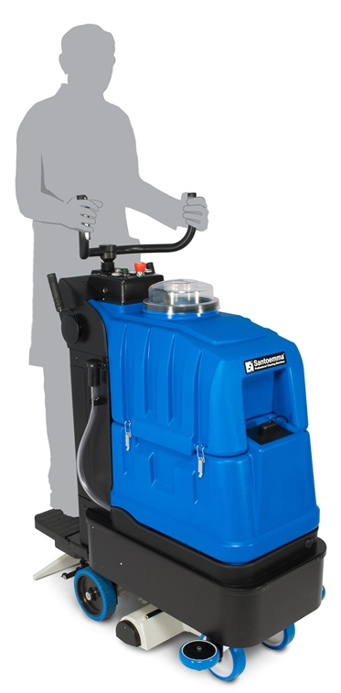
Nikita-Mini is a “step-on” carpet cleaning machine. It is ideal for medium and large areas of carpet and it is able to clean up to 9000 sqft of carpet in 1 hour. In a single pass, a 20” strip of carpet is sprayed with a concentrated chemical solution, brushed by a cylindrical brush, rinsed and vacuumed.
With a 3 stage high-waterlift vacuum system, Nikita-Mini can leave the carpet almost completely dry after the cleaning process. It is possible to perform a maintenance low-moisture cleaning or a restorative deep-cleaning.
Turning a lever and using a specific chemical, Nikita-Mini can be used to clean the carpet with the “Encapsulation” cleaning system.
Moreover, with the optional squeegee SQ720M, Nikita-Mini can be transformed into a powerful step-on scrubber drier.
The machine is equipped with a differential drive motor that gives it excellent manoeuvrability in any place.

Main application fields: cleaning companies, hotels, conference halls, offices, banks, cinemas, theatres, airports, schools, universities, shopping centres, places of worship, mosques and all places with large surfaces of carpet.

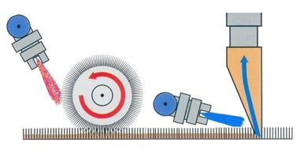

NIKITA-MINI cleaning system

Advantages of Nikita-Mini:

- It is possible to clean up to 9000 sqft in one hour. The cost for cleaning each square meter is dramatically reduced. It is finally possible to clean thousands square meters in short time, with no effort.
- Very light to operate even on thick carpet and on slopes thanks to the driving motor with adjustable speed.
- The special battery pack supplied with the machine, working with the Spiralcell technology, allows: long autonomy, higher number of battery cycles, more flexibility with partial or complete discharges, longer auto-discharge time.
- The special batteries and the 25A charger supplied with the machine allow very fast recharging (about 4 hours for a machine with completely empty batteries).
- Pre-spray, brushing and rinsing are performed in a single pass. Thanks to the complete cleaning cycle, carpet is left completely clean and without sticky chemical residuals. Therefore, it will re-soil much more slowly compared to other cleaning systems.
- Integrated SMARTKIT system allows automatic chemical dosing in each situation.
- Possibility to perform a maintenance cleaning with Encapsulation cleaning system, by simply turning a lever.
- Possibility to clean both carpet and hard floor with a single machine by using the optional squeegee SQ720M. The squeegee is connected to the machine thanks to a quick disconnect coupling and does not require to use any tool.
- The 3 stages high waterlift vacuum system allows an excellent suction and therefore deep dirt removal and very short drying time.
- The special profile of the vacuum heads allows an excellent suction.
- The sprung vacuum heads allow the best suction also in case of uneven floor.
- It is possible to regulate the pressure of the vacuum heads according to the carpet thickness.
- Possibility to adjust the height of the rotating brush according to the kind of carpet or floor and also according to the degree of dirt.
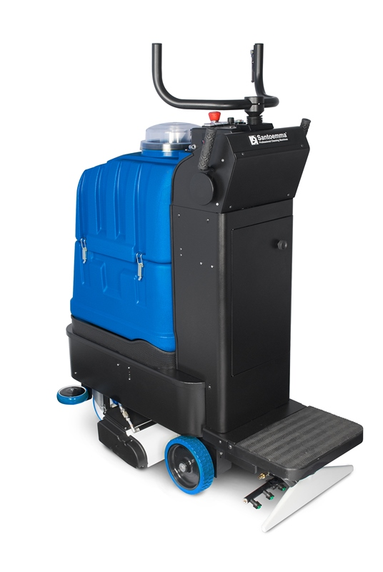
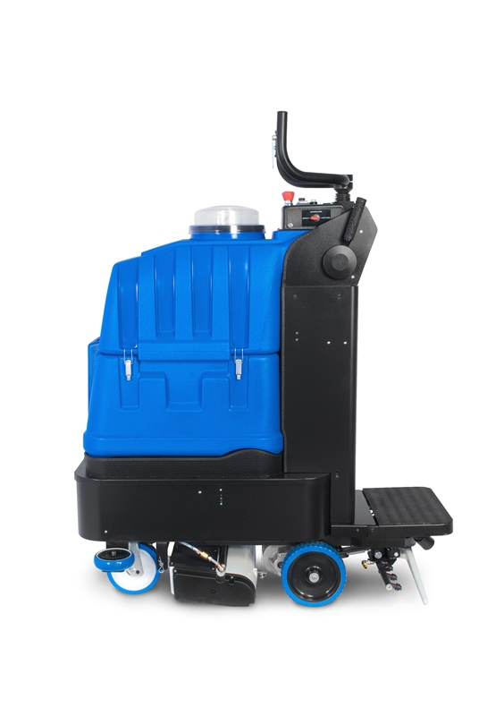
- Possibility to connect the machine with optional tools for cleaning hard-to-reach corners.
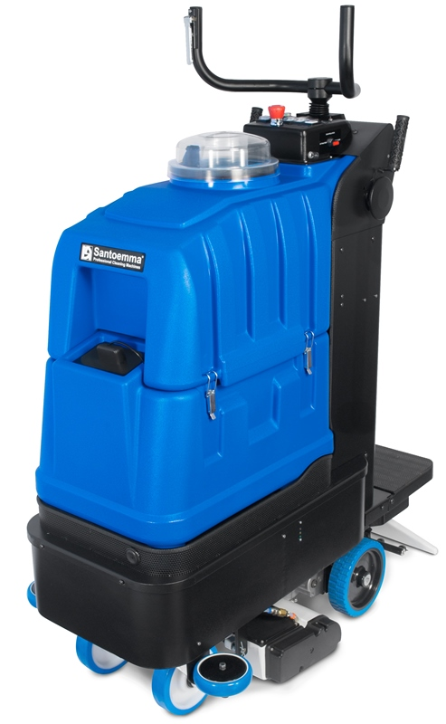

Other technical advantages of Nikita-Mini

- High density polyethylene tanks, very strong and made for lasting a long time.
- Transparent unbreakable cover, which allows to see the dirty water while it is sucked.
- Easy to reach hole for filling the tank with clean water.
- Drain hose for easily emptying the recovery tank.
- Vacuum motor with thermal protection against overload.
- The motor of the rotating brush is powerful and reliable and allow a very deep cleaning.
- Brush motor with thermal protection against overload (useful in case of a wrong regulation of the brush height).
- Vacuum motor treated against rust.
- Both motor and pump can work continuously.
- Quick disconnect spray nozzles, which can be removed without using any tool. The whole spray-bar can be removed from the machine for an easy and comfortable cleaning of the spray nozzles.
- Stainless steel brush bearings for a longer life.
- Modular design that makes the maintenance easier. The maintenance of the machine can be done at low costs.
Technical Data
Approximate performance*: | 4500-9000 sqft
Recovery tank capacity: | 13 Gal
Solution tank capacity: | 13 Gal
Vacuum motor:  Power:  Maximum waterlift:  Maximum air-flow: | 3 stages – High Waterlift  850 W  100” H₂O  12 gal/sec.
Pump with by-pass:  Power:  Maximum pressure:  Maximum water-flow | Membrane  80 W  9 bar  1 gal/min
Drive motor: | 350W – adjustable speed  with differential
Automatic dosing system: | Integrated
Pre-spray system: | Integrated
Cleaning width (carpet/floor): | 20”
Number of nozzles: | 6+5
Brush: | 100W  840 rot/min  24”
Cable length:
Hose length: | optional
Weight (machine body): | 525 lbs including batteries
Weight (packaged machine): | 630 lbs including batteries
Dimensions: | 20x47x49 Inches
Package dimensions: | 32x47x60 Inches
Standard colours: | Blue
Tank construction: | High density polyethylene
Batteries: | 3 x 12V fast charging type  75Ah
*The effective performance depends on the type of cleaning required: restorative deep cleaning - maintenance cleaning.

Complete machine for carpet cleaning, including:
3 batteries 12V- 75Ah each
25A battery charger

Suggested optional tools
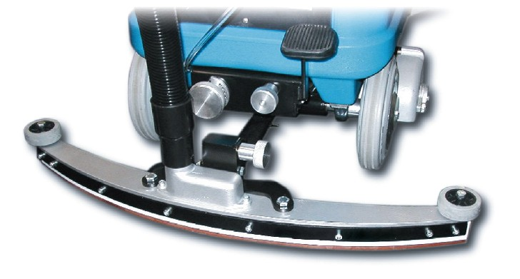 | SQ720M | 28” Squeegee for hard floor cleaning
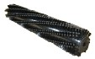 | 369-30 | Brush specific for hard floor cleaning.
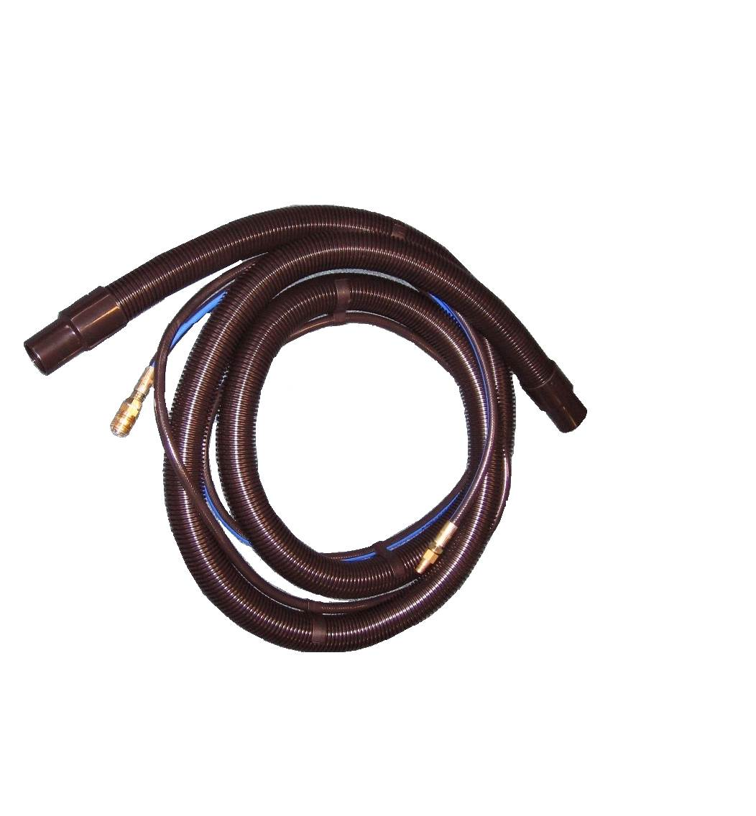 | H35- RAGNOL50-T | Vacuum and solution hoses, 16.5 ft, Ragno solution pipe
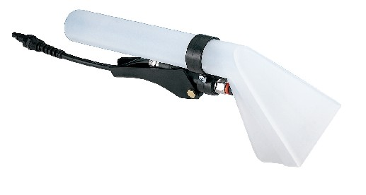 | NS10PN-M | Plastic hand tool, with 1 spray nozzle.
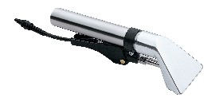 | NS10ALL-M | Aluminium hand tool, with 1 spray nozzle
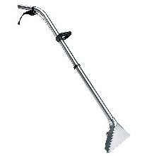 | NS300-M | Carpet tool with aluminium head, 3 spray nozzles, tubes in stainless steel
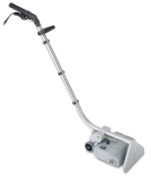 | NS270BRUSH | Special wand, 11” wide, with a cylindrical rotating brush, to be used for cleaning carpet in combination with an injection-extraction machine
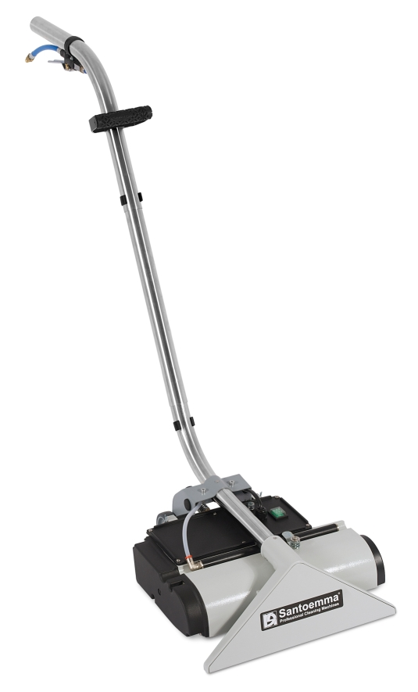 | NS400BRUSH | Special wand, 16” wide, with a cylindrical rotating brush, to be used for cleaning carpet in combination with an injection-extraction machine
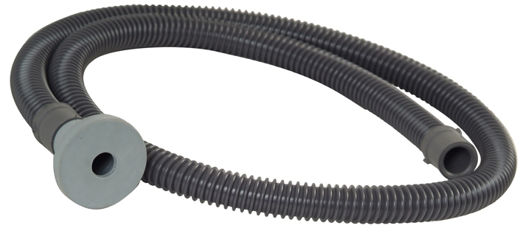 | 9022 | Hose for filling up the clean water tank easily. It can be used to connect the water tap to the machine tank, without spilling water.
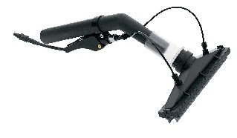 | HERMES-M | Tool which allows to wash and dry walls and windows. The solution is injected by 2 nozzles, which are inside the vacuum head, so that it is possible to clean a vertical surface without water dropping on the floor. Hermes is supplied with a brush slide and a rubber slide, to clean rough or smooth surfaces.
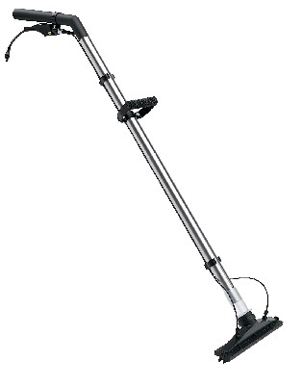 | NS270P-M | This tool works with the same principle of Hermes. Its two extensions allow to wash and dry hard floors, high walls and even ceilings.
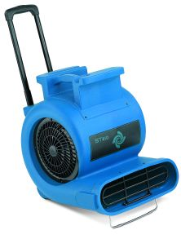 | ST810 | Three speed air blower, high performance, 1 Hp, 230V – 50Hz, for quick drying of carpet after cleaning. Equipped with wheels and extensible handle, easy to transport. Stackable.

